Løsning 1: Home Assistant med ESP

<https://www.zwaves.dk/viewtopic.php?f=37&t=2814&start=120>

Kode

<https://github.com/nic6911/Wavin-AHC-9000-mqtt>

<https://github.com/dkjonas/Wavin-AHC-9000-mqtt>

* Fork with support for MAX13487 insted of MAX3072E

<https://github.com/niklascp/Wavin-AHC-9000-mqtt>

Hardware

DK shop

* <https://elektronik-lavpris.dk/p129673/oky3502-dc-dc-step-down-konverter-4-35vdc-123-30vdc-3a-print/>
* <https://elektronik-lavpris.dk/p82770/max3485cpa-rs485-422-transc-33v-dip8/>

Ebay

* NodeMCU Lua Amica V2 ESP8266 ESP12F Module CP2102 WiFi IoT Unsoldered Arduino DIY  
  <https://www.ebay.de/itm/143790404692>
* DC-DC 3V 5V 12V 24V 36V 48V Buck Adjustable Step Down Voltage Converter Module  
  <https://www.ebay.de/itm/272806096268>
* 10pcs MAX3485 TTL to RS485 UART Converter Serial Adapter Module 3.3V-5V for Node  
  <https://www.ebay.de/itm/185483701909>

Kasse

Eks <https://www.harald-nyborg.dk/forgreningsdaase-85-x-85-mm-staenktaet>

Instrument Case Enclosure Boxes Waterproof Cover Project Electronic Project Box  
<https://www.ebay.de/itm/394608660578>

ABS Waterproof Junction Box Housing Transparent Clear  
<https://www.ebay.de/itm/194901589939>

Løsning 2: OpenHab

Openhab

<https://www.lav-det-selv.dk/forum/t/210932/s/anbefaling-af-smart-home-gulvvarme/pg/7>

Venstre: Fra Nilan Connection guide Højre: Fra JA-121T guide

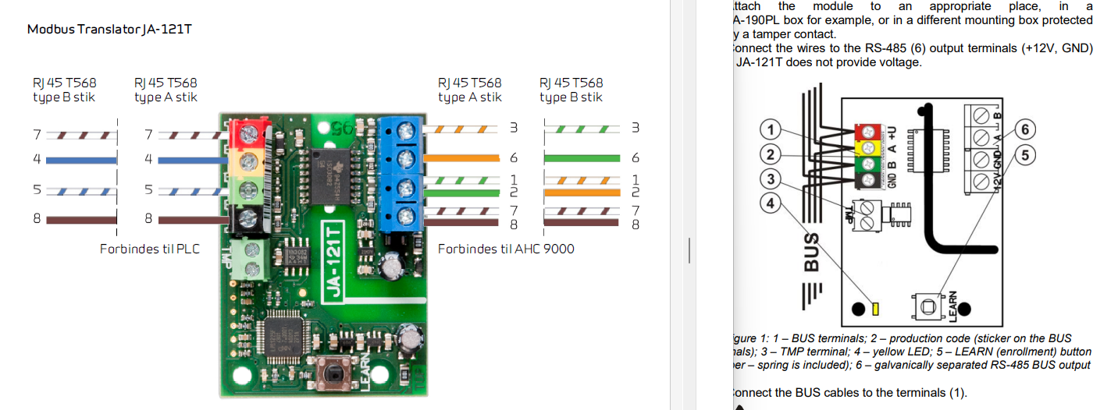

Fra Wavin guide

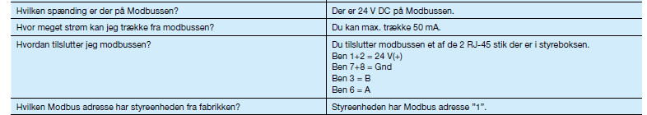

I dette eksempel forbindes Wavin ben 3 **B** til JA board ben **B**.

I dette eksempel forbindes Wavin ben 6 **A** til JA board ben **A**.

MAX3485 har ikke en RE/DE pin som er forbundet til D1 i det oprindelige design. Man kan blot ignorer D1.

<https://github.com/dkjonas/Wavin-AHC-9000-mqtt/issues/1>